1. **Create new database**



1. **Show Database**

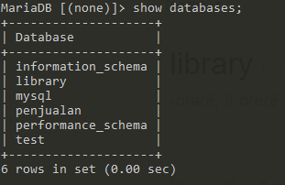

1. **Create Tabel in database library**



1. **Inserting data Into table**

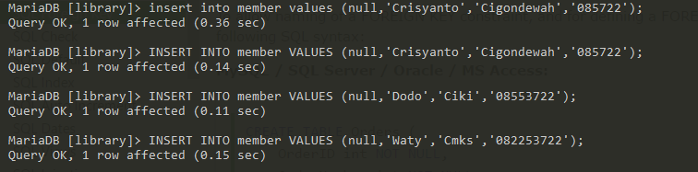

1. **INNER JOIN**

The INNER JOIN keyword selects records that have matching values in both tables.

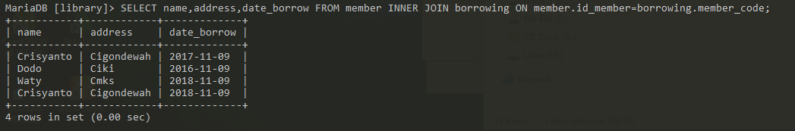

1. **UNION**

The UNION operator is used to combine the result-set of two or more SELECT statements.

* Each SELECT statement within UNION must have the same number of columns
* The columns must also have similar data types
* The columns in each SELECT statement must also be in the same order

* The UNION operator selects only distinct values by default. To allow duplicate values, use UNION ALL:

(Union)

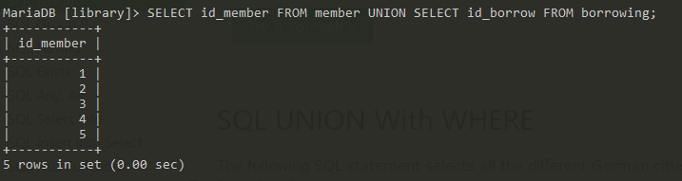

(Union ALL)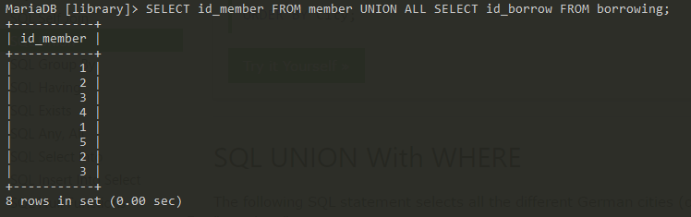

1. **Self Join**

A self JOIN is a regular join, but the table is joined with itself.

<SELECT A.name AS name1, B.name AS name2, A.address FROM member A, member B where A.id_member <> B.id_member AND A.address=B.address ORDER BY A.address;>

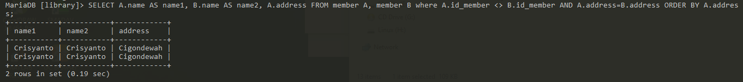

1. **Left Join**

The LEFT JOIN keyword returns all records from the left table (table1), and the matched records from the right table (table2). The result is NULL from the right side, if there is no match.

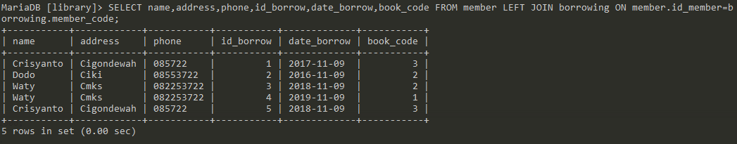

1. **Right Join**

The RIGHT JOIN keyword returns all records from the right table (table2), and the matched records from the left table (table1). The result is NULL from the left side, when there is no match.

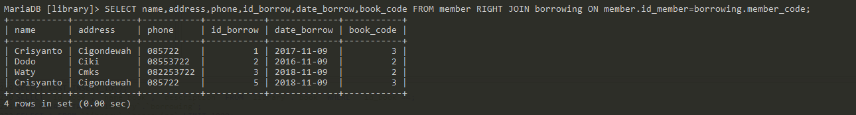

1. **Cartesian Join**

The CARTESIAN JOIN or CROSS JOIN returns the Cartesian product of the sets of records from two or more joined tables. Thus, it equates to an inner join where the join-condition always evaluates to either True or where the join-condition is absent from the statement.

